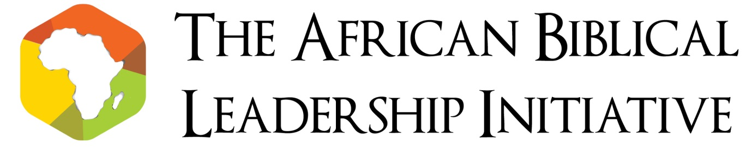
ABLI Malawi: Declaration, 2015
We, the gathered members of the African Biblical Leadership Initiative (ABLI) 2015, reaffirm our belief that the Bible has an important role to play in the Public, and not just Private, life.
As leaders from across the political spectrum, from across the business world, from all parts of the Church gathered and from every corner of Africa, we recognise that our leadership is subject to the sovereignty of God.
And we believe that in the Bible is to be found the wisdom, guidance, inspiration and injunction to moral courage through which Africa can prosper.
When we become fearful of those who are unlike us, the Bible tells us to love our neighbour as ourselves. When we feel like aggression is the only way, the Bible reminds us that blessed are the peacemakers. When we are tempted to cut a corner, the Bible warns us that God will not forget the cheating of dishonest scales. When we become caught up in our status and self-importance we remember the words; the first shall be last. When we disregard corruption and its affects, we glimpse justice rolling on like a river, and righteousness like a never-failing stream.
Therefore; we commend both sides of the conflict in South Sudan for their willingness to take the first step on the journey to peace. We bless all the people of South Sudan and commit ourselves to welcoming them fully into the family of African nations.
We call on all African Leaders to set an example for the next generation in both actions and words, and to offer a hopeful vision such that they are inspired to continue the job of building the Common Good in Africa.
Recognising the scourge of disease on the continent we rededicate ourselves to the cause of physical as well as spiritual healing and call upon the churches to become partners in and agents of a healing power that brings relief and preventive understanding of the causes of ill health and suffering.
We appeal to all African societies to welcome the strangers in their midst, particularly migrants and refugees fleeing persecution. Equally, we challenge the oppressive regimes of this continent to respect the right to life, the rule of law, freedom of belief and freedom of speech. Your actions have not gone unnoticed, either by us or by God.
We offer our hand to the Muslim communities in our midst and say; we respect you, and we love you. So let there be no compulsion in religion, let each person follow their conviction and let us live in peace.
We commit ourselves to the highest standards of Biblical integrity. We refuse to be complicit in corruption in either personal or professional lives.
In all of this, we call on the International Community to stand with and not over Africa.
In all of this, we call on African nations to relate to one another with solidarity and not suspicion.
In all of this, we ask for God’s blessing over Africa.

